WEEK-5 REACT HANDS-ON

1.ReactJS-HOL

App.js:
import React from 'react';

function App() {
return (
<div>
<h1>Welcome to the first session of React</h1>
</div>
);
}

export default App;

OUTPUT:
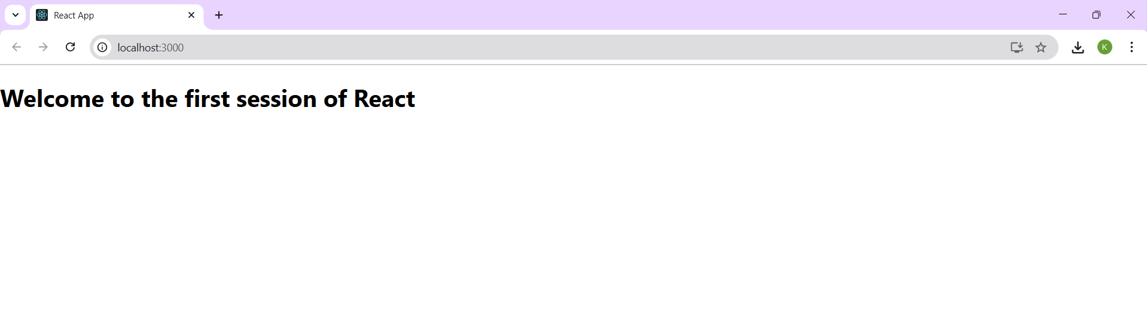

2. ReactJS-HOL

Home.js:
import React from 'react';

function Home() {
return (
<div>
<h2>Welcome to the Home page of Student Management Portal</h2>
</div>
);
}
export default Home;

About.js:
import React from 'react';

function About() {
return (
<div>
<h2>Welcome to the About page of the Student Management Portal</h2>
</div>
);
}
export default About;

Contact.js:
import React from 'react';
function Contact() {
return (
<div>
<h2>Welcome to the Contact page of the Student Management Portal</h2>
</div>
);
}
export default Contact;

App.js:
import React from 'react';
import './App.css';
import Home from './Components/Home';
import About from './Components/About';
import Contact from './Components/Contact';

function App() {
return (
<div className="App">
<h1>Student Management Portal</h1>
<Home />
<About />
<Contact />
</div>
);
}
export default App;

OUTPUT:
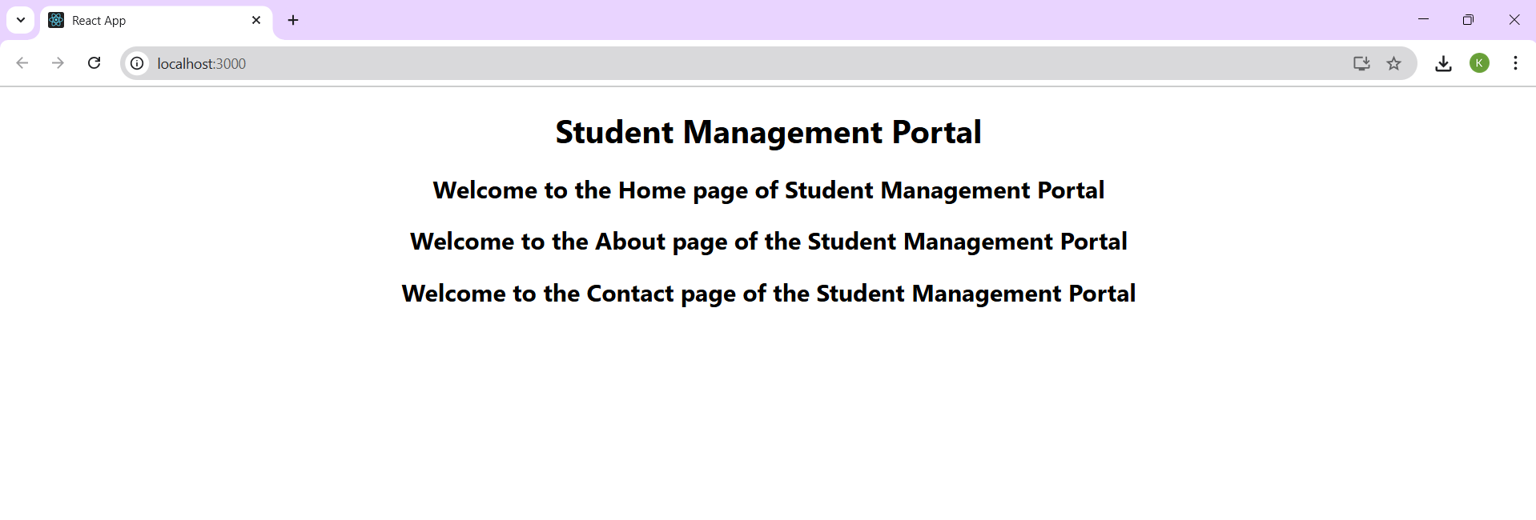

3. ReactJS-HOL

CalculateScore.js:
import './Stylesheets/mystyle.css';

const percentToDecimal = (decimal) => {
return (decimal.toFixed(2) + '%');
}

const calcScore = (total, goal) => {
return percentToDecimal(total / goal);
}

export const CalculateScore = ({ Name, School, total, goal }) => (
<div className="formatstyle">
<h1><font color="Brown">Student Details:</font></h1>

<div className="Name">
<b><span> Name: </span></b>
<span>{Name}</span>
</div>

<div className="School">
<b><span> School: </span></b>
<span>{School}</span>
</div>

<div className="Total">
<b><span>Total: </span></b>
<span>{total}</span>
<span> Marks</span>
</div>

<div className="Score">
<b>Score: </b>
<span>
{calcScore(total, goal)}
</span>
</div>
</div>
);

mystyle.css:
.Name {
font-weight: 300;
color: blue;
}

.School {
color: crimson;
}

.Total {
color: darkmagenta;
}

.formatstyle {
text-align: center;
font-size: large;
}

.Score {
color: forestgreen;
}

App.js:
import './App.css';
import { CalculateScore } from './Components/CalculateScore';
function App() {
return (
<div className="App">
<CalculateScore Name={"Arjun"}
School={"WPS"}
total={284}
goal={3}/>
</div>
);
}
export default App;

OUTPUT:
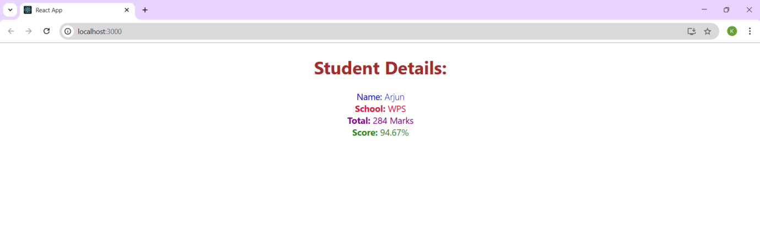

4. ReactJS-HOL

Post.js:
import React from 'react';

class Post extends React.Component {
render() {
const { title, body } = this.props;
return (
<div className="post">
<h2>{title}</h2>
<p>{body}</p>
</div>
);
}
}
export default Post;

Posts.js:
import React from 'react';
import Post from './Post';

class Posts extends React.Component {
constructor(props) {
super(props);
this.state = {
posts: [],
};
}
loadPosts = () => {
fetch('https://jsonplaceholder.typicode.com/posts')
.then(response => response.json())
.then(data => this.setState({ posts: data }))
.catch(error => alert("Error fetching posts: " + error));
};
componentDidMount() {
this.loadPosts();
}
render() {
const { posts } = this.state;
return (
<div>
<h1>Blog Posts</h1>
{posts.map(post => (
<Post key={post.id} title={post.title} body={post.body} />
))}
</div>
);
}
componentDidCatch(error, info) {
alert("Something went wrong: " + error);
}
}
export default Posts;

App.js:
import React from 'react';
import './App.css';
import Posts from './Posts';

function App() {
return (
<div className="App">
<Posts />
</div>
);
}
export default App;

OUTPUT:
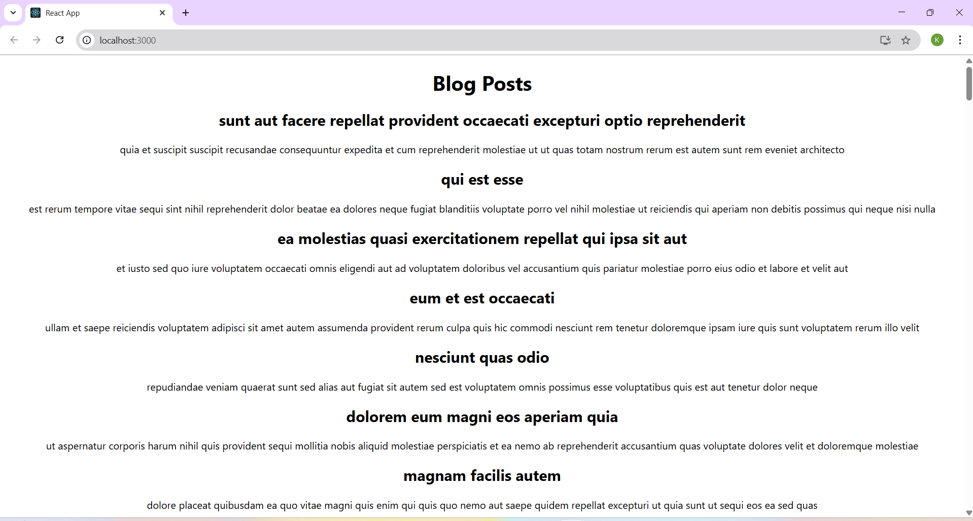

5. ReactJS-HOL

CohortDetails.module.css:

.box {
width: 300px;
display: inline-block;
margin: 10px;
padding: 10px 20px;
border: 1px solid black;
border-radius: 10px;
}

dt {
font-weight: 500;
}

CohortDetails.js:
import React from 'react';
import styles from './CohortDetails.module.css';

function CohortDetails({ props }) {
return (
<div className={styles.box}>
<h3 style={{ color: props.cohort.currentStatus === "Ongoing" ? "green" : "blue" }}>
{props.cohort.cohortCode}-
<span>{props.cohort.technology}</span>
</h3>
<dl>
<dt>Started On</dt>
<dd>{props.cohort.startDate}</dd>
<dt>Current Status</dt>
<dd>{props.cohort.currentStatus}</dd>
<dt>Coach</dt>
<dd>{props.cohort.coachName}</dd>
<dt>Trainer</dt>
<dd>{props.cohort.trainerName}</dd>
</dl>
</div>
);
}
export default CohortDetails;

OUTPUT:




